Our best pictures from Morgan Academy’s first Iftar party for the end of Ramadan
Senior pupils organised the bash where they broke their fast together in the school hall.
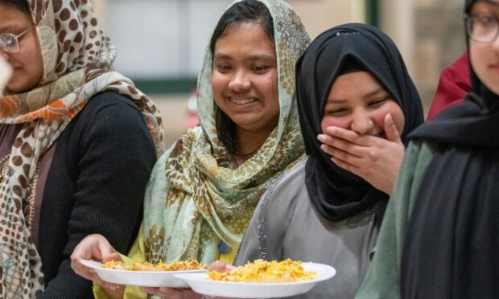
Pupils had fun and a feast. Image: Kim Cessford / DC Thomson.
by Cheryl PeeblesApril 20 2023, 9.32am
Share0Comment
Schools newsletter - Reports, analysis and tips to help you and your family.

Email addressSign up

The Muslim holy month of Ramadan is coming to a close – and Morgan Academy has thrown a party to celebrate.
Senior pupils organised the Dundee school’s first ever Iftar party, where they broke one of their final fasts with friends.
And our photographer Kim Cessford was there to capture the fun as scores of Morgan pupils enjoyed the evening meal of Iftar together.
Many of the school’s pupils have been fasting daily from sunrise to sunset throughout Ramadan, which began on March 22 and ends on Friday with the festival of Eid al-Fitr.

Party organised by pupils
More than quarter of Morgan Academy’s pupils are Muslim, and we met two of them early in Ramadan to find it what it’s like fasting during the school day.
Wednesday evening was the first time the school has hosted an Iftar party.
And the S5 and S6 organising students, including Raheen Ashgar, Ameer Hamza, Aleeza Yusaf and Haajirah Arshad, were keen to use the event to share Ramadan with non-Muslim friends.

Pictures from Morgan Academy Iftar party
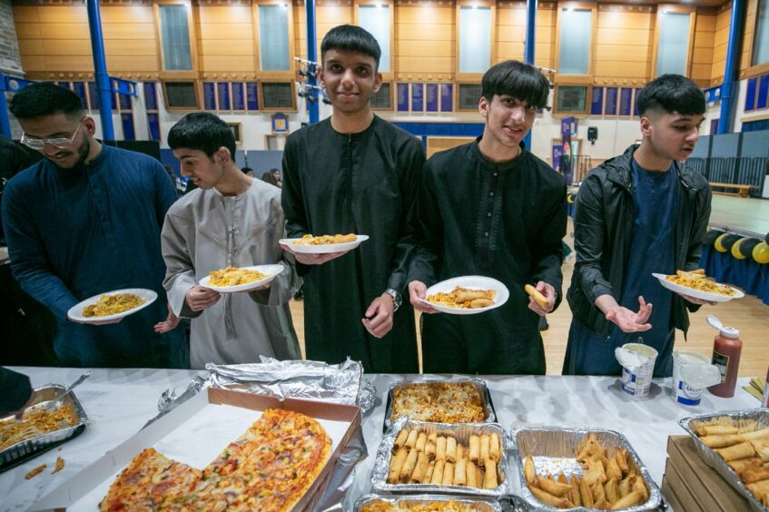
Breaking the fast together at Morgan’s first Iftar party. Image: Kim Cessford / DC Thomson.
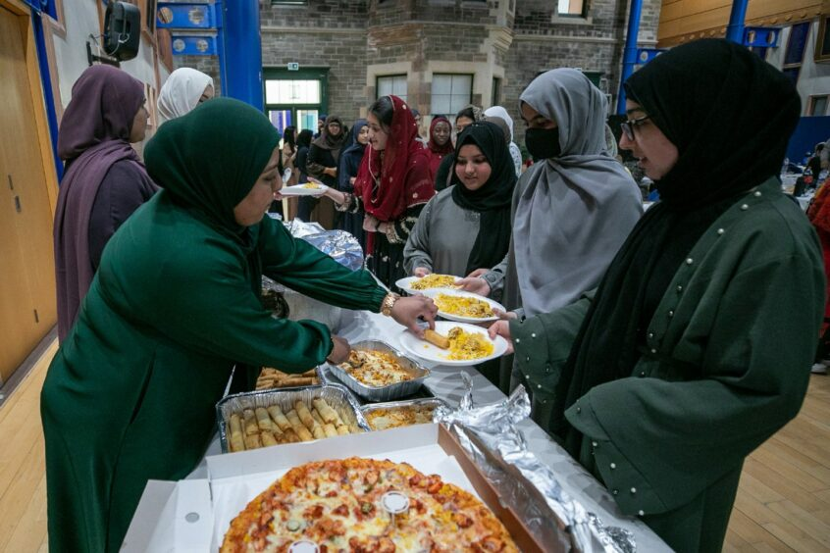
A feast was prepared for the party. Image: Kim Cessford / DC Thomson.
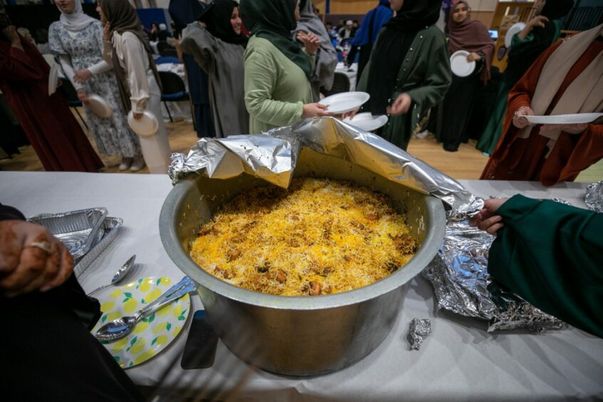
One of the delicious-looking dishes on offer. Image: Kim Cessford / DC Thomson.
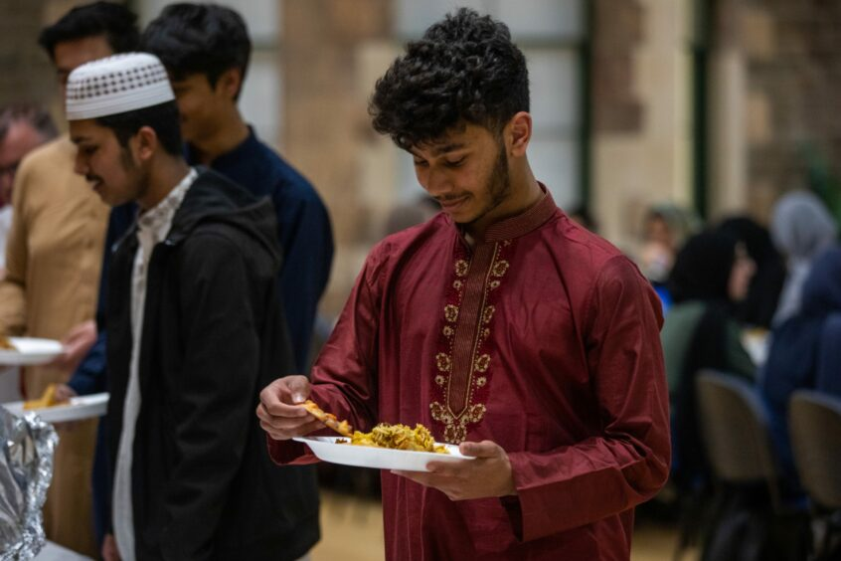
Iftar is the evening meal during Ramadan. Image: Kim Cessford / DC Thomson
Lots of dishes were prepared for the students. Image: Kim Cessford / DC Thomson
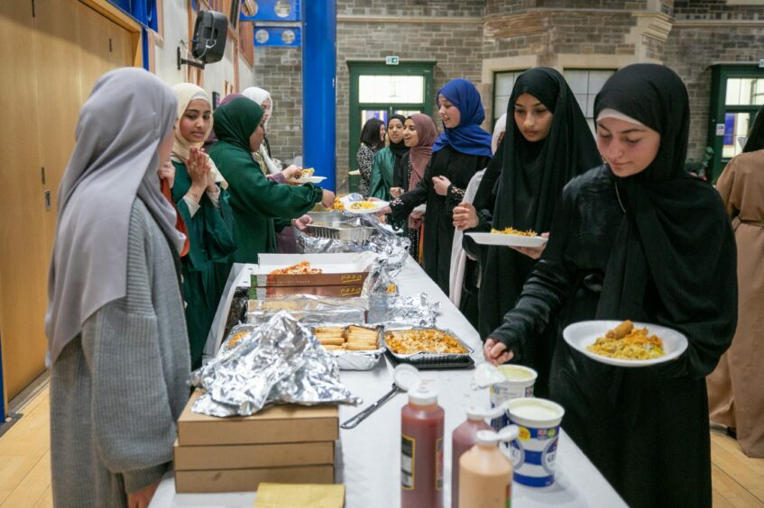
Pupils had been looking forward to eating Iftar together. Image: Kim Cessford / DC Thomson.
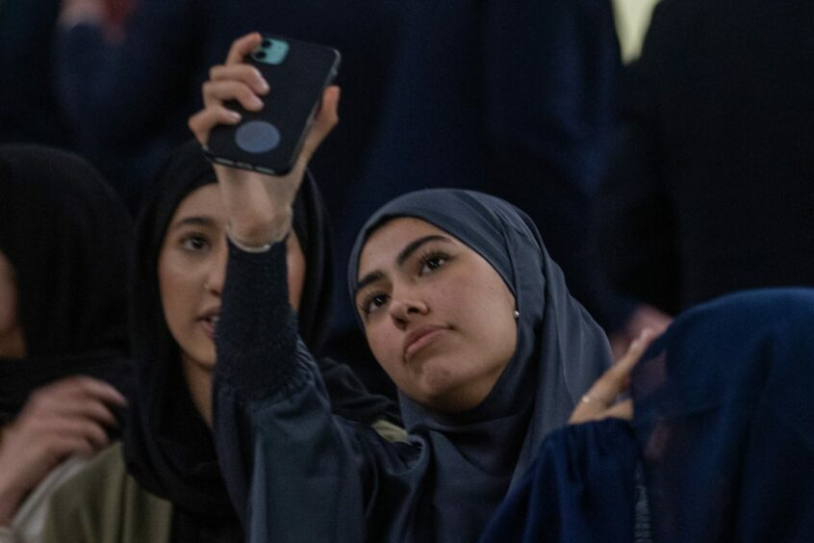
Time for a selfie. Image: Kim Cessford / DC Thomson.
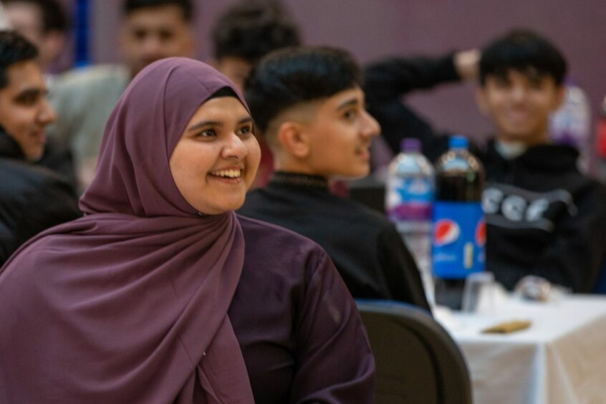
Youngsters sat down to dine together. Image: Kim Cessford / DC Thomson.
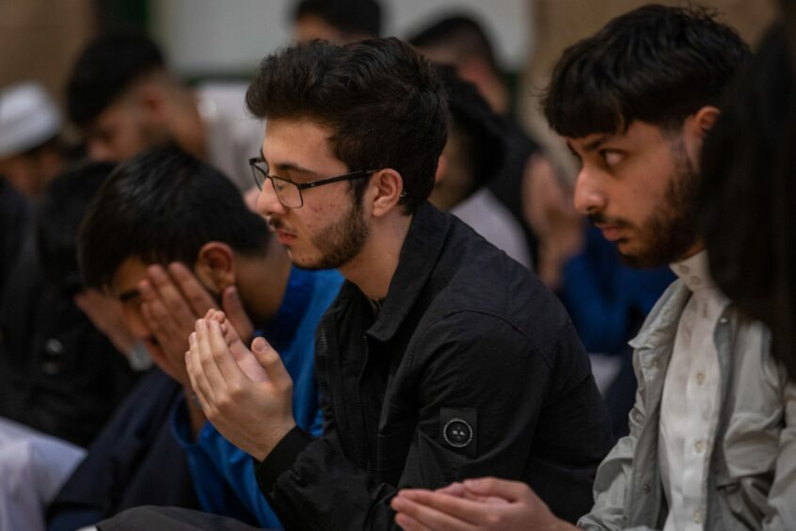
The party was held in Morgan Academy school hall. Image: Kim Cessford / DC Thomson.
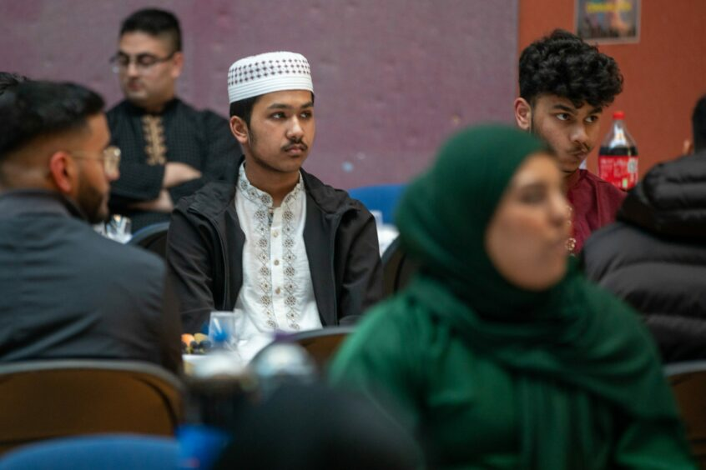
There was also time for serious reflection amid the celebration. Image: Kim Cessford / DC Thomson.
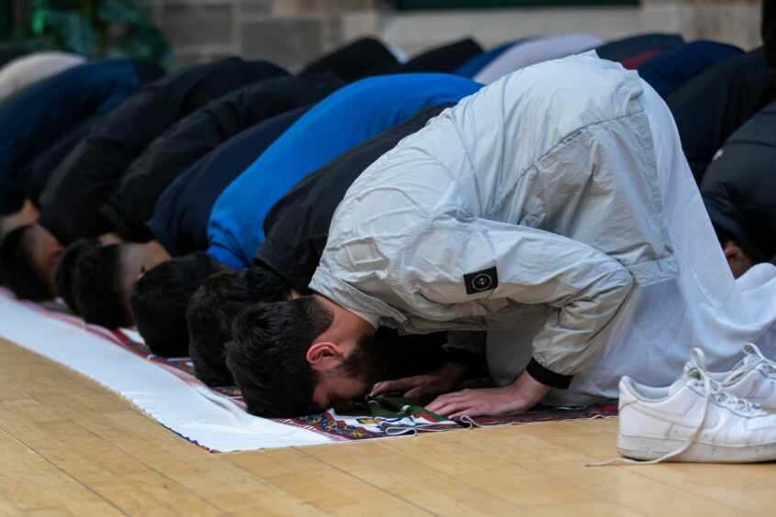
Pupils joined in prayer during the party. Image: Kim Cessford / DC Thomson.
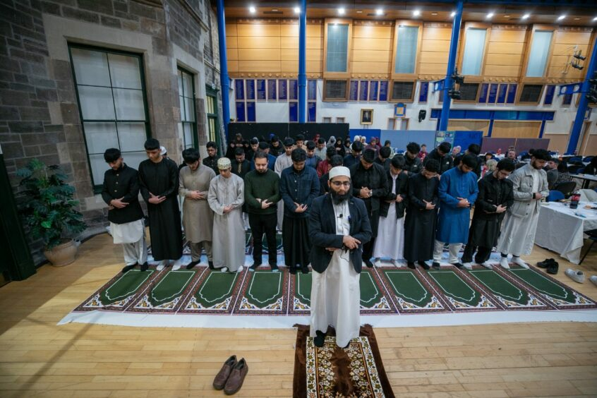
Imam Hamza from Dundee Central Mosque led prayers. Image: Kim Cessford / DC Thomson.
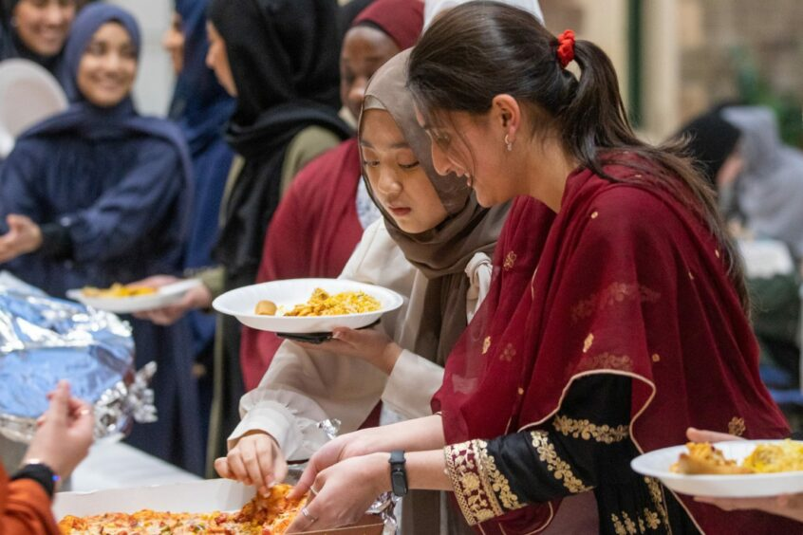
Pupils were eager to tuck into the feast. Image: Kim Cessford / DC Thomson.
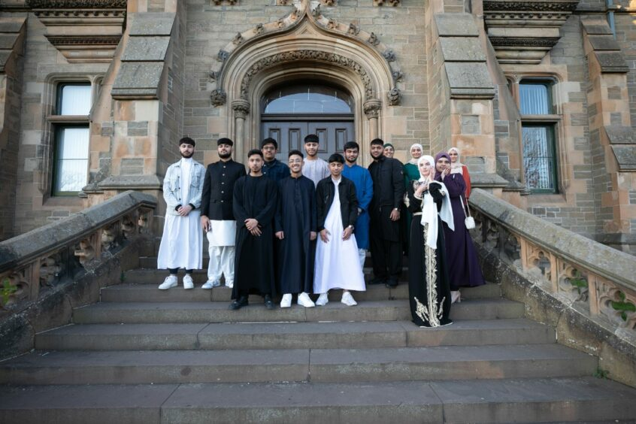
S5 and S6 pupils who organised the event gathered for a snap at the school entrance. Image: Kim Cessford / DC Thomson.
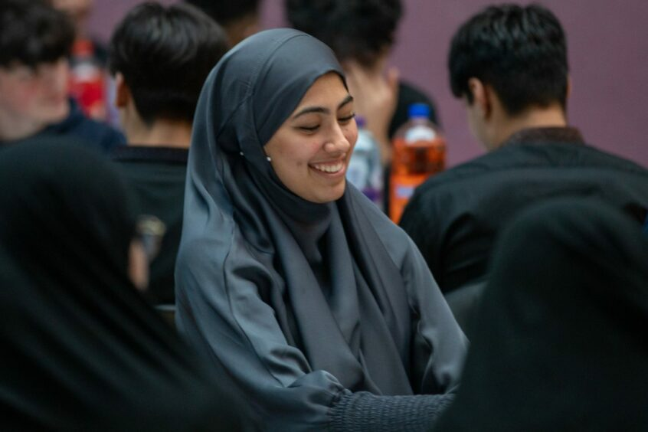
Young people enjoyed gathering together for one of the final evenings of Ramadan. Image: Kim Cessford / DC Thomson.
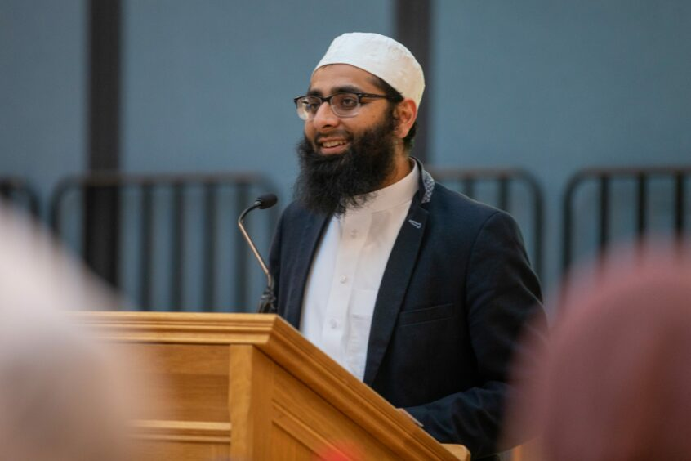
Imam Hamza, from Dundee Central Mosque, was among the guests. Image: Kim Cessford / DC Thomson.
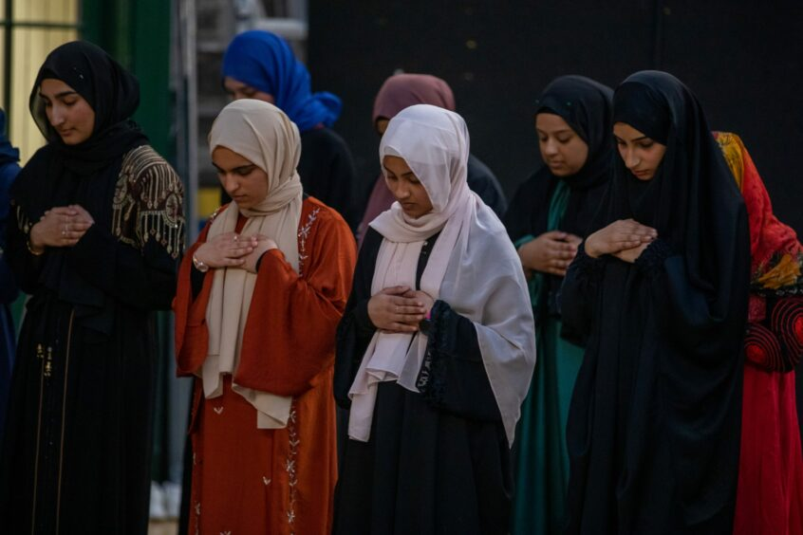
Girls in prayer. Image: Kim Cessford / DC Thomson.
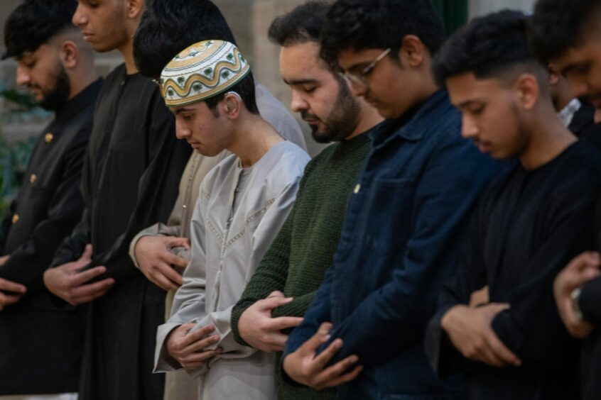
And boys in prayer. Image: Kim Cessford / DC Thomson.
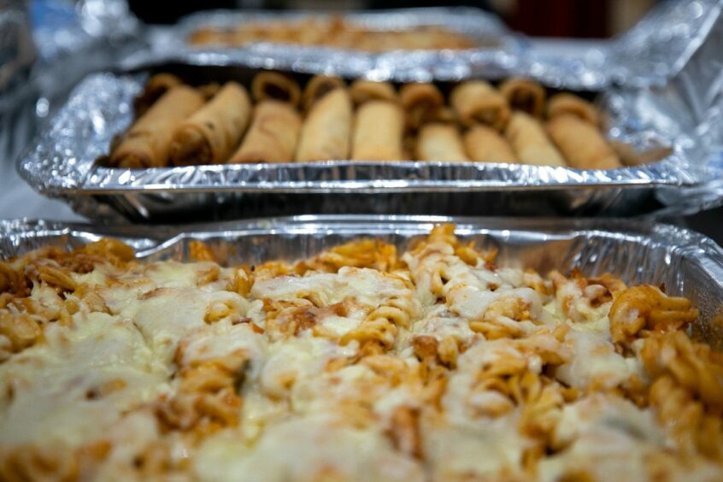
Some of the impressive looking spread. Image: Kim Cessford / DC Thomson.

